**KL University**



**Department of Computer ScienceEngineering**

**Course code -15CS2007**

**Database Systems**

**II B.Tech – 2 ndSemester**

**Academic Year 2016-2017**

**Project Based Lab**

**ON**

**ONLINE SHARE TRADING**

**Submitted by**

**B.AMRUTHA(150030084)**

**K.SRUJANA(150030498)**

**Section – S2**

**Batch No: 28**

|  |  |  |
| --- | --- | --- |
| Student ID | Student Name | Department |
| 150030084 | B.AMRUTHA | CSE |
| 150030498 | K.SRUJANA | CSE |

**K L University**

**DEPARTMENT OF COMPUTER SCIENCE ENGINEERING**

**(DST-FIST Sponsored Department)**



**CERTIFICATE**

This is to certify that the course based project entitled **“ONLINE SHARE TRADING”**IsabonafideworkdonebyB.AMRUTHA(150030084),K.SRUJANA(150030498)in partial fulfillment of the requirement for the award of degree in **BACHELOR OF TECHNOLOGY** in **Computer Science Engineering** during the academic year **2016-2017.**

**Faculty In Charge Head of the Department**

**A.SATYA KALYAN Prof. Srikanth Vemuru**

**DEPARTMENT OF COMPUTER SCIENCE ENGINEERING**

**(DST-FIST Sponsored Department)**



**DECLARATION**

We hereby declare that this project based lab report entitled “**ONLINE SHARE TRADING**” has been prepared by us in partial fulfillment of the requirement for the award of degree “**BACHELOR OF TECHNOLOGY in COMPUTER SCIENCE ENGINEERING**” during the academic year 2016-2017.

We also declare that this project based lab report is of our own effort and it has not been submitted to any other university for the award of any degree.

**Date:**

**Place: Vaddeswaram**

|  |  |
| --- | --- |
| **Name** | **Student ID** |
| **B.AMRUTHA** | **150030084** |
| **K.SRUJANA** | **150030498** |

# ACKNOWLEDGMENTS

The satisfaction that accompanies that the successful completion of any task would beincomplete without the mention of people whose ceaseless cooperation made it possible, whose constant guidance and encouragement crown all efforts with success.

We are grateful to our project based Lab guide **A.SATYA KALYAN** Computer Science and Engineering for the guidance, inspiration and constructive suggestions that helped us in the completion of this project.

At the outset, we thank our Head of the Department **Dr.V. Srikanth** for the moral support and the excellent facilities provided. I would also like to thank all the teaching and non-teaching staff members of Computer Science department who have extended their full cooperation during course of my project based labs.

We wish to express our warm and grateful thanks to our project coordinator for the guidance and assistance he provided in completing our project successfully.

We thank all my friends who helped me sharing knowledge and by providing material to complete the project based lab in time.

**PROJECT ASSOCIATES**

|  |  |
| --- | --- |
| **Name** | **Student ID** |
| **B.AMRUTHA** | **150030084** |
| **K.SRUJANA** | **150030498** |

Table of Contents

Abstract 6

Introduction 7

PROJECT DESCRIPTION 8

List of Entities & Attributes 9

ER Diagram (Conceptual Model) 10

Schema Diagram 11-13

Normalization & Final List of Relations 14-16

Create & Insert SQL Queries 17-27

SQL Queries related to Report Generation 28-30

Conclusion 31

# Abstract

Online trading of shares and DMAT account All the leading banks in India are providing Dematerialization (DMAT) accounts to their customers. The criteria for getting DMAT account is the customer requires SB account in the same bank in any branch. The DMAT will provide the details of shares holding in the account. The customer may sell or buy the shares from/to the account. The minimum criteria for buying shares are the customer requires amount required to buy shares. The criteria for selling shares the customer requires the balance of shares in DMAT account. **Procedure to Buy a share(s):** The customer requires balance amount in the SB account, the required amount is to be blocked for buying shares from market. Customer will identify the shares from the stock market, the amount of shares required. The shares are to be purchased in two ways (1) Market price: The shares will be confirmed as per the current market price. (2) Limit price: The shares will be confirmed as the price will come down to limit price. Once the shares are confirmed, the required amount plus commission will be transferred to bank account. The shares will be transferred to DMAT account. **Procedure to sell share(s):** The customer needs balance of shares in DMAT account. The customer will identify the shares needs to sell in the market. The shares are to be sold in two ways. (1) Market price: The shares will be confirmed as per the current market price. (2) Limit price: The shares will be confirmed as the price will reach the limit price. The sold shares will be transferred to bank account. The amount minus commission will be transferred to bank account.

# Introduction

  Database is an organized collection of data. The data is typically organized to model aspects of reality in a way that supports processes requiring information. A DBMS makes it possible for end users to create, read, update and delete data in a database. The DBMS essentially serves as an interface between the database and end users or application programs, ensuring that data is consistently organized and remains easily accessible. The DBMS manages three important things: the data, the database engine that allows data to be accessed, locked and modified and the database schema, which defines the database’s logical structure. These three foundational elements help provide concurrency, security, data integrity and uniform administration procedures. The DBMS can offer both logical and physical data independence. That means it can protect users and applications from needing to know where data is stored or having to be concerned about changes to the physical structure of data.

The main purpose of maintaining database for Online Share Trading management is it reduces the manual work. We can store all data in the database with the help of computer. Online [trades](http://www.investopedia.com/terms/t/trade.asp) has increased the number of discount brokerages because internet trading allows many [brokers](http://www.investopedia.com/terms/b/broker.asp) to further cut costs and part of the savings can be past on to customers in the form of lower [commissions](http://www.investopedia.com/terms/c/commission.asp). Another benefit of online trading is the improvement in the speed of which transactions can be executed and settled, because there is no need for paper-based documents to be copied, filed and entered into an electronic format. This program also helps us to know the present status of a products to the customer that is whether the product is delivered or not and bill received or not.

# PROJECT DESCRIPTION

In this project Online Share Trading we created a database which stores the product , customer and their sbi,dmat account details. Dmat account will be provide only if the customer have the sbi account .customer can sell or buy the products. If the customer want to sell the product he/she should have the sufficient products in his/her dmat account or if a customer want to buy product he/she should have the enough balance in his/her sbi account and there will be two kinds of prices those are limit price and market price. Based on this information we have drawn an er diagram which is a conceptual model for Online Share Trading. With that we have designed a schema for the online share trading database. With the help of the schema diagram we have created the tables for the database and have inserted the relevant values in to those tables. After inserting the values in to the tables we have executed or implemented some queries to test whether it is showing the expected data.

# List of Entities & Attributes

|  |  |
| --- | --- |
| **ENTITES** | **ATTRIBUTES** |
| CUSTOMER | Cust_id, cust_name, phno, address(city, state, pin), email |
| BANK | Bank_id,branch_id, bank_name,email,phno,address(state,city,pin) |
| SHARE | Shareid,share%,companyname,companyid |
| TRADER | Trader id,trader name,address(state,city,pin),email,phno |
| BANK ACCOUNT | Acc_id,acc_name,acc type |
| DMAT ACCOUNT | dmat_id, acc _num,acc_name,acc_paswd |

# ER Diagram (Conceptual Model)

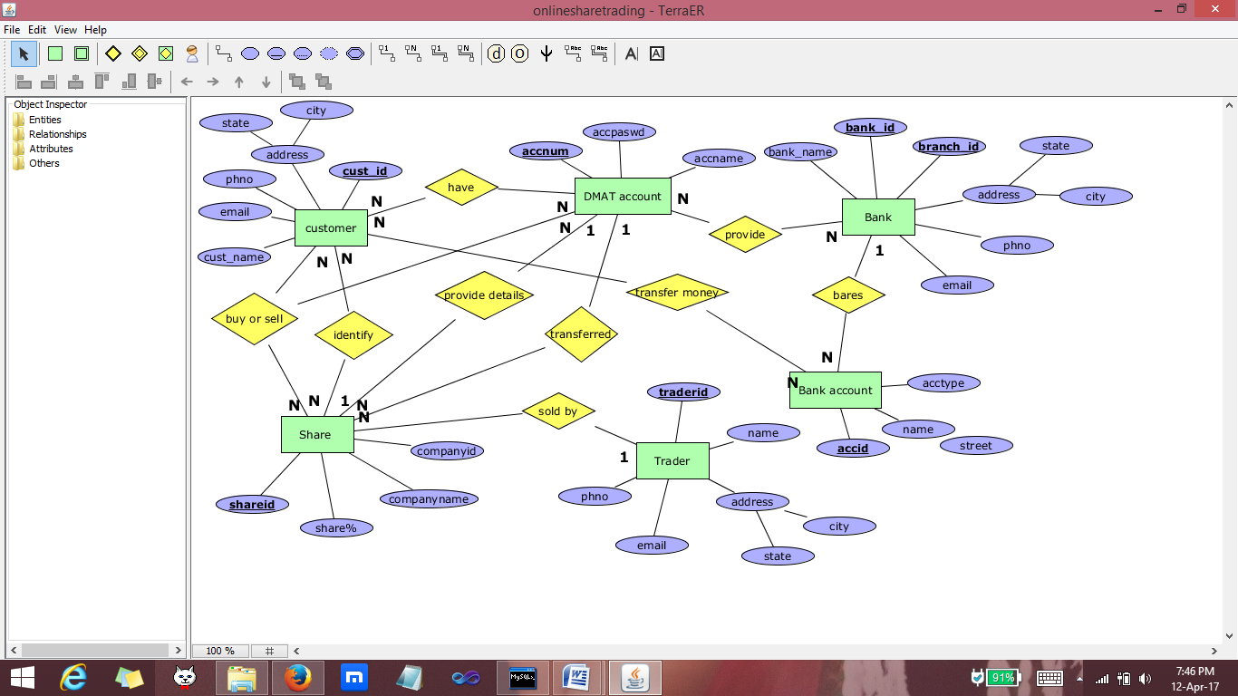

# Schema Diagram

|  |
| --- |
| **CUSTOMER** |
| Custid (pk) |
| Cust_name |
| State |
| City |
| Street |
| Phno |
| Email |

|  |
| --- |
| **SHARE** |
| Shareid(pk) |
| Shareamount |
| Accnum(fk) |
| Traderid(fk) |
| Companyid(pk)(fk) |

|  |
| --- |
| **BANK** |
| Branchid(pk) |
| Bankname |
| State |
| City |
| Street |
| Bankid(pk) |
| Phno |
| Email |

|  |
| --- |
| **TRADER** |
| Traderid(pk) |
| Tradername |
| State |
| City |
| Street |
| Email |
| Phno |

|  |
| --- |
| **BANK ACCOUNT** |
| Bankaccid(pk) |
| Bankaccname |
| Bankid(pk)(fk) |

|  |
| --- |
| **CUSTOMER_SHARES** |
| Custid(pk)(fk) |
| Shareid(pk)(fk) |

|  |
| --- |
| **CUSTOMER_DMAT account** |
| Custid(pk)(fk) |
| Accnum(pk)(fk) |

|  |
| --- |
| **CUSTOMER_SHARE_**  **DMAT Account** |
| Custid(pk)(fk) |
| Shareid(pk)(fk) |
| accnum(pk)(fk) |

|  |
| --- |
| **CUSTOMER_MONEY_BANK** |
| Custid(pk)(fk) |
| Bankaccid(pk)(fk) |
| Bankid(pk)(fk) |

|  |
| --- |
| **BANK_PROVIDE_DMAT account** |
| accnum(pk)(fk) |
| Bankid(pk)(fk) |

|  |
| --- |
| **DMAT Account** |
| Accnum(pk) |
| Accpassword |
| Accname |

|  |
| --- |
| **SHARE_COMPANY** |
| Companyid(pk) |
| Companyname |

# Normalization & Final List of Relations

**NORMALISED TABLES:**

|  |
| --- |
| **CUSTOMER** |
| Custid (pk) |
| Cust_name |
| State |
| City |
| Phno |
| Email |

|  |
| --- |
| **SHARE** |
| Shareid(pk) |
| Shareamount |
| Accnum(fk) |
| Traderid(fk) |
| Companyid(pk)(fk) |
| comapnyname |

|  |
| --- |
| **TRADER** |
| Traderid(pk) |
| Tradername |
| State |
| City |
| Email |
| Phno |

|  |
| --- |
| **BANK** |
| Branchid(pk) |
| Bankname |
| State |
| City |
| Bankid(pk) |
| Phno |
| Email |

|  |
| --- |
| **BANK ACCOUNT** |
| Bankaccid(pk) |
| Bankaccname |
| Bankid(pk)(fk) |
|  |

|  |
| --- |
| **CUSTOMER_DMAT account** |
| Custid(pk)(fk) |
| Accnum(pk)(fk) |

|  |
| --- |
| **CUSTOMER_SHARES** |
| Custid(pk)(fk) |
| Shareid(pk)(fk) |

|  |
| --- |
| **CUSTOMER_SHARE_**  **DMAT Account** |
| Custid(pk)(fk) |
| Shareid(pk)(fk) |
| accnum(pk)(fk) |

|  |
| --- |
| **CUSTOMER_MONEY_BANK** |
| Custid(pk)(fk) |
| Bankaccid(pk)(fk) |
| Bankid(pk)(fk) |

|  |
| --- |
| **BANK_PROVIDE_DMAT account** |
| accnum(pk)(fk) |
| Bankid(pk)(fk) |

|  |
| --- |
| **DMAT Account** |
| Accnum(pk) |
| Accpassword |
| Accname |

# **create & Insert** SQL **Queries**

----------------------------------------------------------------------------------------------------------------

CREATING TABLES

----------------------------------------------------------------------------------------------------------------

1) create table customer(custid int,cust_name varchar(50),state varchar(30),

city varchar(30),street varchar(30),phno int,email varchar(70),primary key(custid));

2)create table bank(bankid int,branchid int,bankname varchar(50),state varchar(50),city varchar(50),street varchar(50),phno int,email varchar(100),primary key(bankid,branchid));

3)create table trader(traderid int,tradername varchar(50),state varchar(50),city varchar(50),street varchar(50),email varchar(100),phno int,primary key(traderid));

4) create table dmataccount(accnum int,accpassword varchar(20),accname varch

ar(30),primary key(accnum));

5) create table share_company(companyid int,companyname varchar(30),primary

key(companyid));

6) create table share(shareid int,shareamount int,accnum int,traderid int,co

mpanyid int,primary key(shareid,companyid),constraint foreign key(companyid) references share_company(companyid),constraint foreign key(traderid) references trader(traderid),constraint foreign key(accnum) references dmataccount(accnum));

7) create table bankaccount(bankaccid int,bankaccname varchar(50),bankid int,primary key(bankaccid,bankid),constraint foreign key(bankid) references bank(bankid));

8) create table customer_shares(custid int,shareid int,primary key(custid,shareid),constraint foreign key(custid) references customer(custid),constraint foreign key(shareid) references share(shareid));

9) create table customer_dmataccount(custid int,accnum int,primary key(custid,accnum),constraint foreign key(custid) references customer(custid),constraint foreign key(accnum) references dmataccount(accnum));

10)create table customer_share_dmataccount(custid int,shareid int,accnum int

,primary key(custid,shareid,accnum),constraint foreign key(custid) references cu

stomer(custid),constraint foreign key(shareid) references share(shareid),constra

int foreign key(accnum) references dmataccount(accnum));

11)create table customer_money_bank(custid int,bankaccid int,bankid int,primary key(custid,bankaccid,bankid),constraint foreign key(custid) references customer(custid),constraint foreign key(bankaccid) references bankaccount(bankaccid),constraint foreign key(bankid) references bank(bankid));

12) create table bank_provide_dmataccount(accnum int,bankid int,primary key(accnum,bankid),constraint foreign key(accnum) references dmataccount(accnum),constraint foreign key(bankid) references bank(bankid));--------------------------------------------------------------------------------------------------------------

INSERTING DATA INTO TABLES

----------------------------------------------------------------------------------------------------------------

BANK:

1) insert into bank(bankid,branchid,bankname,state,phno,email)values(1001,101,"royalbankcanada","canada",10146873,"royalbankcanada@gmail.com");

2)insert into bank(bankid,branchid,bankname,state,phno,email)values(1002,101,"bankofamerica","america",101389327,"americanbank@gmail.com");

3) insert into bank(bankid,branchid,bankname,state,phno,email)values(1003,10

1,"industrial&commercialbankofchina","china",21934804,"industrialcommercialbank@gmail.com");

4) insert into bank(bankid,branchid,bankname,state,phno,email)values(1004,10

1,"bankofindia","india",893478532,"indianbank@gmail.com");

SHARE_COMPANY:

1) insert into share_company values(2001,"bankofamerica");

2) insert into share_company values(2002,"honeywellinternational");

3) insert into share_company values(2003,"americaninternationalgroup");

4) insert into share_company values(2004,"TEConnectivity");

5) insert into share_company values(2005,"Bristowgroup");

BANKACCOUNT:

1) insert into bankaccount values(3001,"chandrasekhar",1004,13402331);

2) insert into bankaccount values(3002,"jones",1001,9483890123);

3) insert into bankaccount values(3003,"jackoline",1001,849310384);

4) insert into bankaccount values(3004,"kimhyunjung",1003,89371084394);

5) insert into bankaccount values(3005,"leeminhoo",1003,24783947894);

6) insert into bankaccount values(3007,"jkrowling",1002,398473294);

7) insert into bankaccount values(3006,"manojkumar",1001,389479);

8) insert into bankaccount values(3008,"ramesh",1001,2938203);

9) insert into bankaccount values(3009,"danielradcliff",1002,2390480);

10) insert into bankaccount values(3010,"gujunpyo",1003,10238024);

11) insert into bankaccount values(3011,"svetlana",1001,30948302);

TRADER:

1) insert into trader values(4001,"ramesh","india","mumbai","rameshtrades123

@gmail.com",985403034);

2) insert into trader values(4002,"danielradcliff","america","losangels","da

niel@gmail.com",1018323432);

3) insert into trader values(4003,"gujunpyo","china","beijing","junpyojun@gm

ail.com",0248932594);

4) insert into trader values(4004,"svetlana","america","chicago","svetlana@g

mail.com",394739592);

DMATACCOUNT:

1) insert into dmataccount values(5001,"11@5001#","jones");

2) insert into dmataccount values(5002,"22@5002#","kimhyunjung");

3) insert into dmataccount values(5003,"33@5003#","chandrasekhar");

4) insert into dmataccount values(5004,"44@5004#","leeminhoo");

5) insert into dmataccount values(5005,"55@5005#","manojkumar");

6) insert into dmataccount values(5006,"66@5006#","ramesh");

7) insert into dmataccount values(5007,"77@5007#","danielradcliff");

8) insert into dmataccount values(5008,"88@5008#","gujunpyo");

9) insert into dmataccount values(5009,"99@5009#","svetlana");

CUSTOMER:

1) insert into customer values(6001,"jones","america","houstan",101832479,"j

ones@gmail.com");

2) insert into customer values(6002,"kimhyunjung","china","beijing",20839031

3,"hyun@gmail.com");

3) insert into customer values(6003,"chandrasekhar","india","kerala",9882234

42,"sekhar@gmail.com");

4) insert into customer values(6004,"leeminhoo","china","beijing",208930843,

"leemin@gmail.com");

5) insert into customer values(6005,"manojkumar","india","banglore",89236842

3,"manoj@gmail.com");

SHARE:

1) insert into share values(7001,32083,5002,4003,2001);

2) insert into share values(7002,3294243,5001,4003,2001);

3) insert into share values(7003,69504,5003,4003,2004);

4) insert into share values(7004,2313,5004,4002,2004);

5) insert into share values(7005,29480,5005,4004,2004);

6) insert into share values(7006,82498,5006,4003,2004);

7) insert into share values(7007,1083219,5007,4001,2003);

8) insert into share values(7008,9138924,5008,4001,2003);

9) insert into share values(7009,2042,5009,4001,2003);

CUSTOMER_SHARES:

1) insert into customer_shares values(6001,7002);

2) insert into customer_shares values(6001,7004);

3) insert into customer_shares values(6001,7005);

4) insert into customer_shares values(6001,7007);

5) insert into customer_shares values(6002,7001);

6) insert into customer_shares values(6002,7003);

7) insert into customer_shares values(6002,7004);

8) insert into customer_shares values(6002,7008);

9) insert into customer_shares values(6003,7002);

10) insert into customer_shares values(6003,7009);

11) insert into customer_shares values(6003,7004);

12) insert into customer_shares values(6004,7001);

13) insert into customer_shares values(6004,7002);

14) insert into customer_shares values(6004,7003);

15) insert into customer_shares values(6005,7004);

16) insert into customer_shares values(6005,7005);

17) insert into customer_shares values(6005,7008);

CUSTOMER_DMATACCOUNT:

1) insert into customer_dmataccount values(6001,5001);

2) insert into customer_dmataccount values(6002,5002);

3) insert into customer_dmataccount values(6003,5003);

4) insert into customer_dmataccount values(6004,5004);

5) insert into customer_dmataccount values(6005,5005);

CUSTOMER_SHARE_DMATACCOUNT:

1) insert into customer_share_dmataccount values(6001,7002,5001);

2) insert into customer_share_dmataccount values(6001,7001,5001);

3) insert into customer_share_dmataccount values(6001,7003,5001);

4) insert into customer_share_dmataccount values(6002,7004,5002);

5) insert into customer_share_dmataccount values(6002,7009,5002);

6) insert into customer_share_dmataccount values(6003,7009,5003);

7) insert into customer_share_dmataccount values(6004,7005,5004);

8) insert into customer_share_dmataccount values(6004,7006,5004);

9) insert into customer_share_dmataccount values(6004,7007,5004);

10) insert into customer_share_dmataccount values(6005,7008,5005);

CUSTOMER_MONEY_BANK:

1) insert into customer_money_bank values(6001,3002,1001);

2) insert into customer_money_bank values(6002,3004,1003);

3) insert into customer_money_bank values(6003,3001,1004);

4) insert into customer_money_bank values(6004,3005,1003);

5) insert into customer_money_bank values(6005,3006,1001);

BANK_PROVIDE_DMATACCOUNT:

1) insert into bank_provide_dmataccount values(5001,1002);

2) insert into bank_provide_dmataccount values(5002,1003);

3) insert into bank_provide_dmataccount values(5003,1004);

4) insert into bank_provide_dmataccount values(5004,1003);

5) insert into bank_provide_dmataccount values(5005,1001);

6) insert into bank_provide_dmataccount values(5006,1002);

7) insert into bank_provide_dmataccount values(5007,1002);

8) insert into bank_provide_dmataccount values(5008,1003);

9) insert into bank_provide_dmataccount values(5009,1004);

# SQL Queries related to Report Generation

**1.** 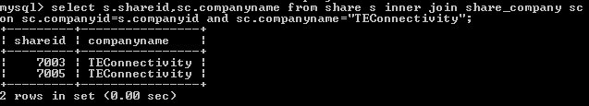

**2.** 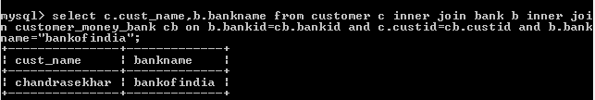

**3.** 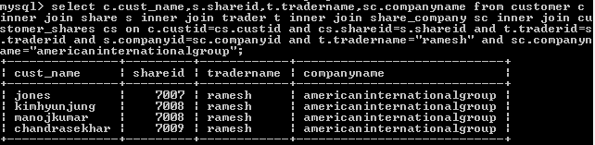

**4.** 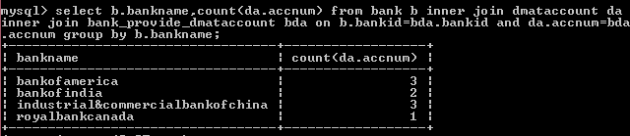

**5.** 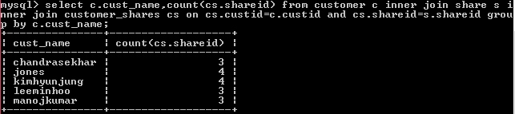

**6.** 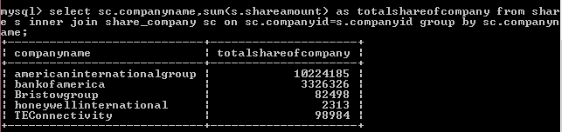

**7.** 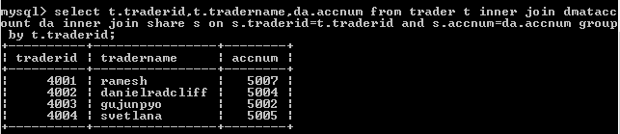

**8.** 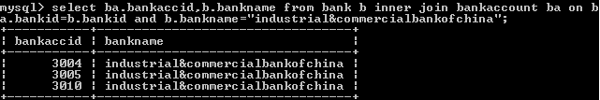

**9.** 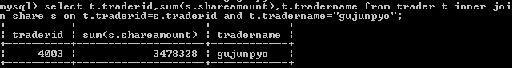

**10.** 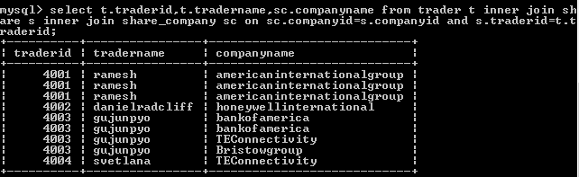

# Conclusion

Online share trading reduces the work that have to be done by the human being. The internet’s arrival and its subsequent popularity in India have made online trading in India, which is about the online purchase and sales of shares, one of the extremely popular means of trading. Both beginner and experienced traders and investors in India are milking this opportunity by trading online in futures and options, stocks and currencies worldwide.

As we know that the constructive uses of new technologies have always contributed positively towards improving human life standards and the economy of a country, such as online trading, in equity markets it increased trade volumes and number of investors trading in stock markets.

Online trading in India is the internet based investment activity that involves no direct involvement of the broker. There are many leading online portals in India along with the online trading platforms of the biggest stock houses like national stock exchange and the Bombay stock exchange.

Since the online share trading is that much important so, we have tried our level best to design a suitable database for online share trading that stores the all information. We believe that we have accomplished our goals and satisfied with the code we developed.